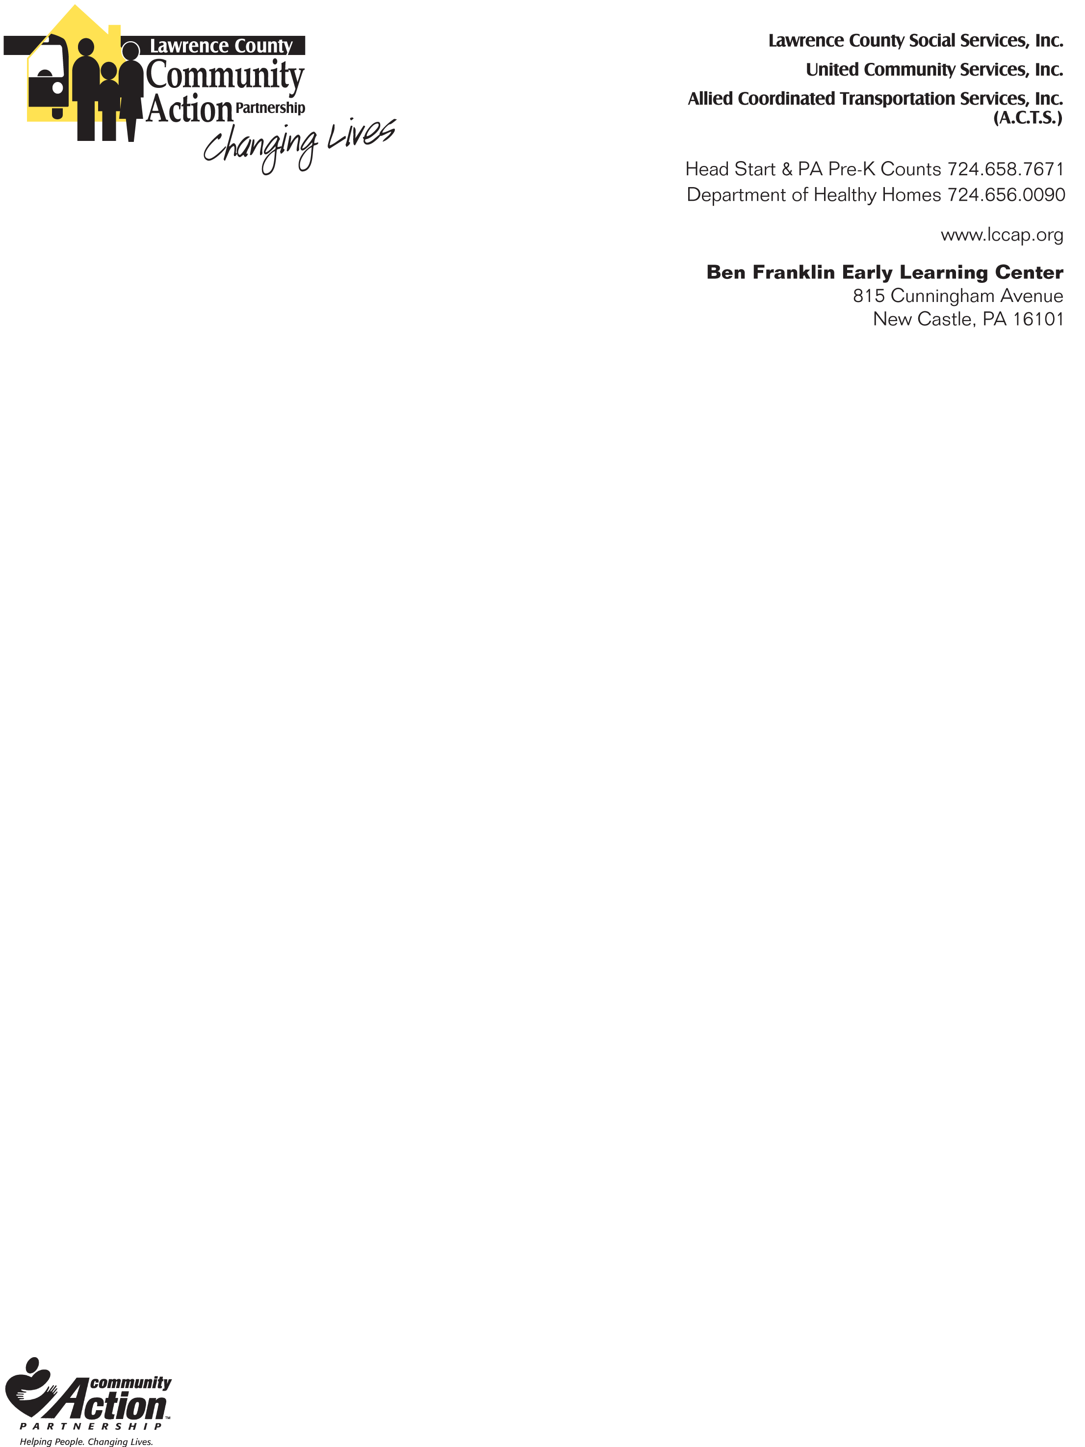
Lawrence County Community Action Partnership
Early Learning Programs

VISION FOLLOW-UP TREATMENT FORM

Child’s Name
Date of Birth |  | Date of Vision Screen

The child above has been screened using the Spot Vision Screener and was recommended for a complete eye exam. We are formally requesting the results of the complete hearing exam be shared with our LCCAP Early Learning Health Services Office.
Fax #: 724-658-7389
Email healthoffice@lccap.org
Provide completed form to parent

Name of Physician (please print): ___________________________________________________

Date of eye exam: _____________________________________________________________

Results of eye exam:

Child passed eye exam

Child referred to Optometrist or other Specialist

Treatment Provided:

