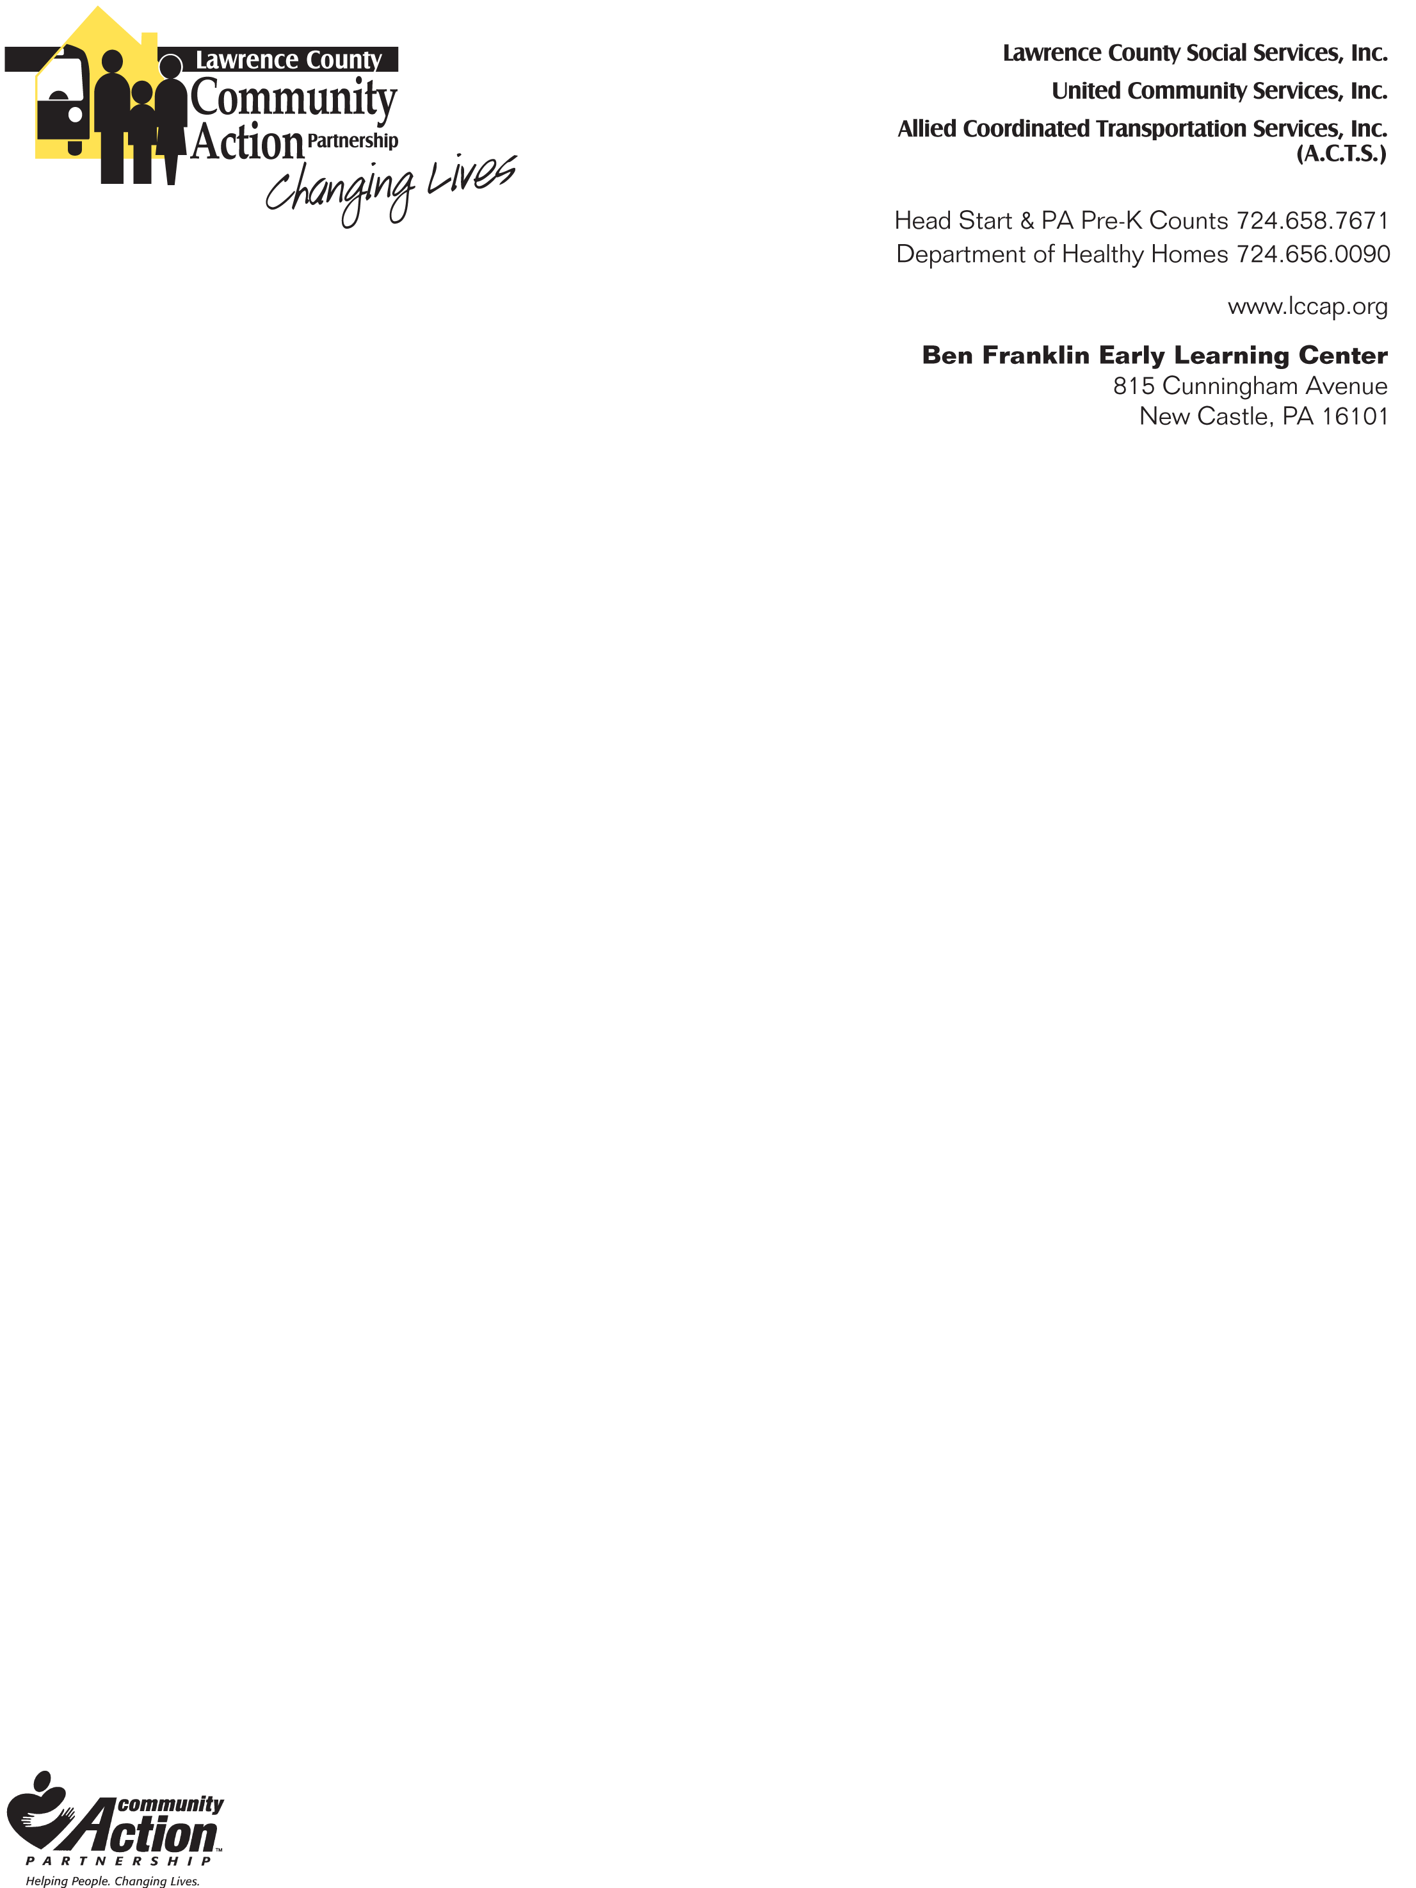
Lawrence County Community Action Partnership
Early Learning Programs

HEARING FOLLOW-UP TREATMENT FORM

Child’s Name
Date of Birth |  | Date of Hearing Screen

The child above has been screened using the Natus Echo Screener III or Bio-Logic AuDX Hearing Screener and was recommended for a complete hearing exam. We are formally requesting the results of the complete hearing exam be shared with our LCCAP Early Learning Health Services Office.
Fax #: 724-658-7389
Email healthoffice@lccap.org
Provide completed form to parent

Name of Physician (please print): ___________________________________________________

Date of hearing exam: _____________________________________________________________

Results of hearing exam:

Child passed hearing exam

Child referred to ENT or other Specialist

Treatment Provided:

